Family Medicaid
Child Support Services



Participant Guide

3/5/09

By the end of this session, participants will be able to

- identify who is required to cooperate with the Office of Child Support Services (OCSS)

- identify the criteria and the process to establish Good Cause for non-cooperation

- apply the appropriate penalty for an individual who fails to cooperate

- correctly budget the income of a penalized individual

- properly complete the appropriate SUCCESS screens

I. Introduction

II. Registration Forms and Facility Information

III. Format of Training

IV. Overview

V. Good Cause

VI. Penalty

VII. Conclusion

Child Support Services
(MR 2250)

Recipients must assign their rights to medical support to the state and cooperate with CSS in locating the non-custodial parent, establishing paternity, and the collection of medical support. Referrals must be made for all absent parents who are not providing health insurance.

Referrals are not required for the following:

- TMA/4MCS
- Child only FM cases
- Child receiving under NB
- Parent receives LIM and the only child receives SSI
- Both natural parents to all children in LIM case
- Pregnant woman for unborn child
- RSM pregnant woman for any child
- LIM minor parent whose child is excluded from the AU
- Minor parent is not receiving as a dependent child
- 18 year olds receiving RSM Child
- Non-custodial parents of a married minor
- Non-custodial parent providing health insurance

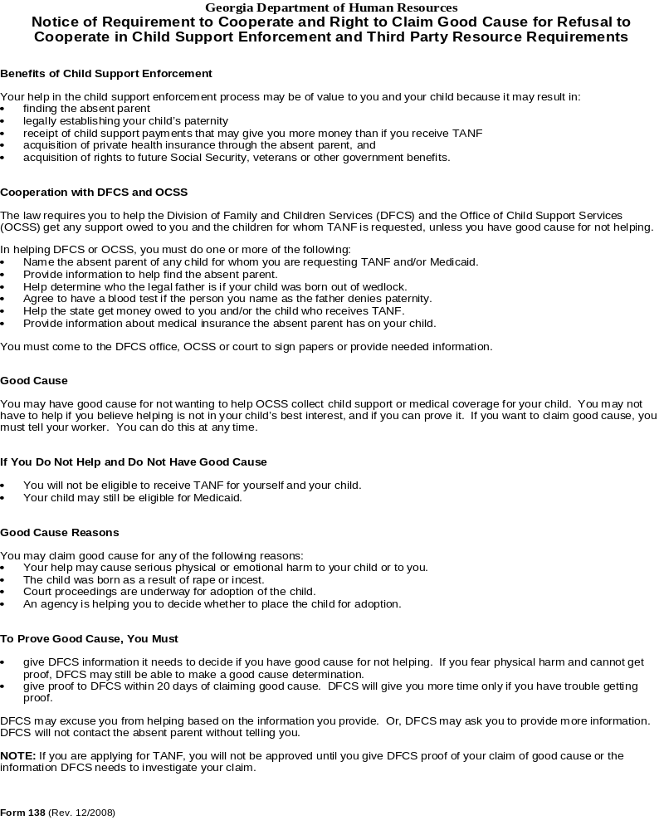
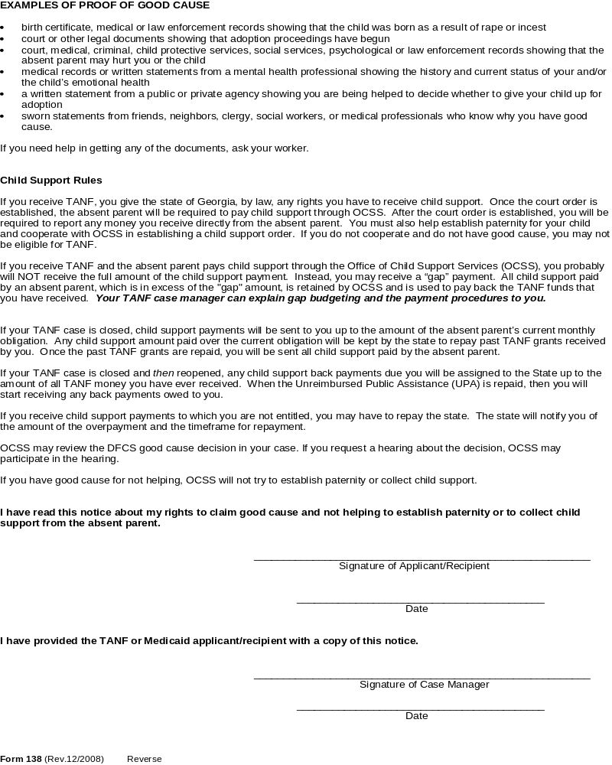

Katherine Norwood Case Study


Katherine Norwood receives LIM for herself and her two children, Lisa and Joey.

During the initial interview, Ms. Norwood provided relevant information regarding the fathers of her children. She stated that John Lawrence is the father of Lisa and provided the Case Manager with his last known address, phone number, demographic information and place of employment.

However, when it came to Joey’s father she was unable to provide any information except for his name, Parker Kent.

All of the information provided by Ms. Norwood was transmitted electronically to the Office of Child Support Services. She was later contacted by OCSS to provide additional information specifically regarding Joey’s father, Parker Kent.

The Case Manager was notified by OCSS that Ms. Norwood failed to cooperate with the process.


SUCCESS
Screens

CHANGE CLIENT DEMOGRAPHIC 1 - DEM1 DEM1 01
Month 11 06 1001 10 05 06

Client Name LISA NORWOOD Suf Client ID XXXX00269

Alt SSA/SSN SSN Appl SSN1 V More DOB V Sex Race Eth
Name Appl For Date SSNs (MM DD YYYY)
522 16 XXXX CS 06 02 1972 CS F B N

GA Marital Living RSM Min Par Boarder Amt Paid -- Family Planning—
Res Status Arrngmt Ad/Ch /LA Num Meals for Meals Referral Date
Y N AH

Concurr SSI Depriv V Prenatal Care ---------- Pregnant --------- FTC
Out of St Recip Ind Good Cse Term/Due Term/Due V Num V Code
CA FS MA Code Date Exp
N N N N A CS

Message
15-lett 16-crs 23-alau

CHANGE ABSENT PARENT IDENTIFICATION - APID APID A
Month 11 06 7691 02 01 06 01 More

HOH Name KATHERINE NORWOOD Del AP AP Returned Home N
AP Name JOHN LAWRENCE Suf
SSN Seq Num 00001

Dep First Last Legal Pat Dep First Last Legal Pat Dep First Last Legal Pat
Name Name Rel Type Name Name Rel Type Name Name Rel Type
01 LISA NEL AK NF 02 JOEY NEL NO NO

IV-D --- Good Cause Claim --- Referral 130 Form UCB Other Income
Coop Ind Rsn Stat Date Date Date Ind Types
Enter Y to indicate that the A/R will cooperate with Child Support Services
Y 10 02 06
Union/Local More APs

Message 0013

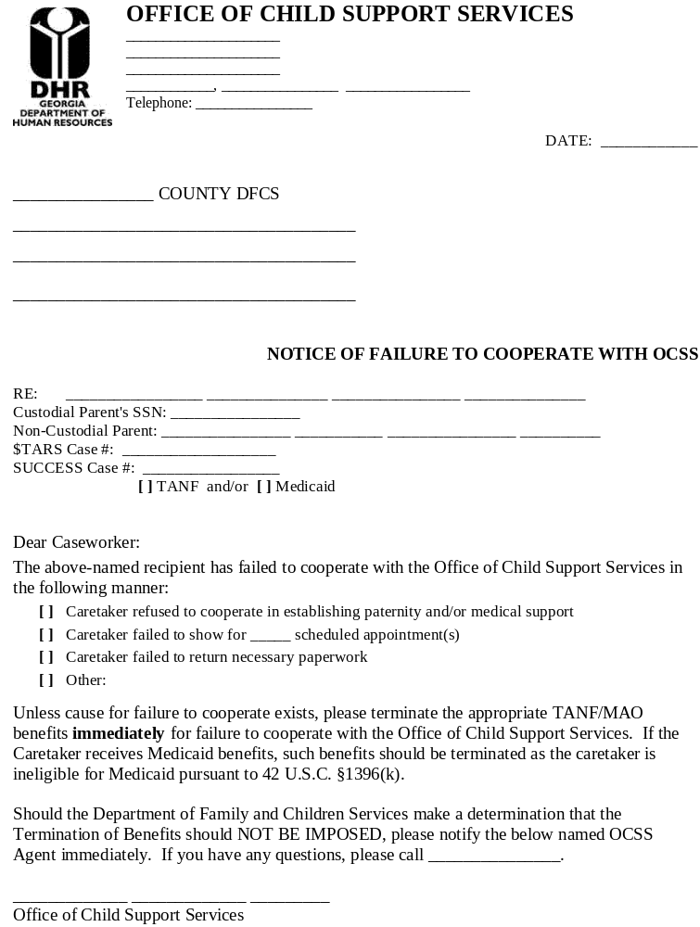

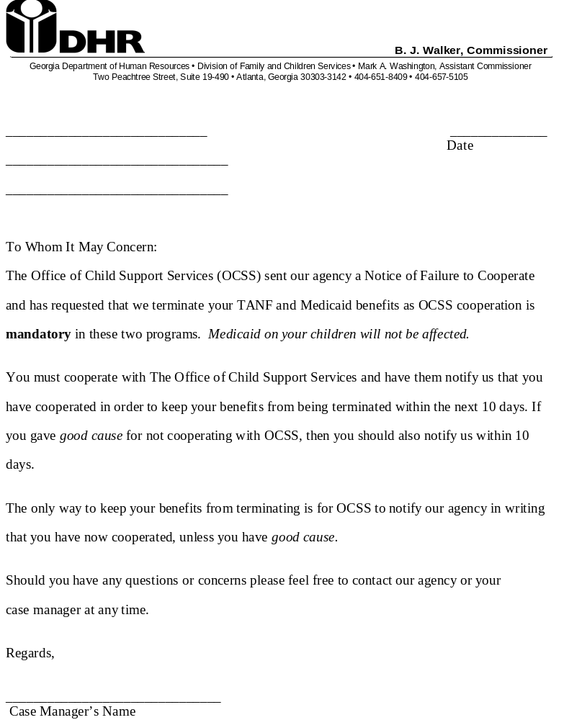

CHANGE ABSENT PARENT IDENTIFICATION - APID APID A
Month 11 06 7691 02 01 06 02 More

HOH Name KATHERINE NORWOOD Del AP AP Returned Home N
AP Name PARKER KENT Suf
SSN Seq Num 00001

Dep First Last Legal Pat Dep First Last Legal Pat Dep First Last Legal Pat
Name Name Rel Type Name Name Rel Type Name Name Rel Type
01 LISA NEL NO NO 02 JOEY NEL PF NF

IV-D --- Good Cause Claim --- Referral 130 Form UCB Other Income
Coop Ind Rsn Stat Date Date Date Ind Types
N 10 02 06
Union/Local More APs
Enter N to indicate that the A/R refuses to cooperate with Child Support Services

Message 0013

Good Cause Reason
AD | Adoption Pending
CH | Potential Emotional Harm Child
CI | Potential Physical Harm Child
PH | Potential Emotional Harm Parent
PI | Potential Physical Harm Parent
RA | Rape/Incest
RE | Release of Parental Right

Good Cause Status
AP | Claim Approved
DE | Claim Denied
DO | Claimed Document Submitted
DP | Documentation Problem
NO | Claimed No Document Submitted
PN | Documentation Pending

Evidence Needed to Substantiate Good Cause Determination
(Chart 2250.1)

Good Cause Circumstance | Proof Required
  Physical and/or emotional harm to the child | Child Protective Services (CPS), court, criminal, law enforcement, medical, psychological or social services records indicating the possibility of physical or emotional harm by the NCP
Physical and/or emotional harm to the grantee relative | Court, criminal, law enforcement, medical, psychological or social services records indicating the possibility of physical or emotional harm by the NCP
Child conceived as a result of rape or incest | Medical or law enforcement records indicating conception resulted from rape or incest
Pending legal adoption proceedings | Court documents or statement from social services indicating that adoption is pending
A public or private social service agency is assisting the A/R in deciding whether to keep the child or release him/her for adoption | Written statement from the public or private social service agency assisting the A/R
Any of the above Good Cause circumstances | Sworn statement from individuals with knowledge of Good Cause circumstances when the above proof cannot be obtained

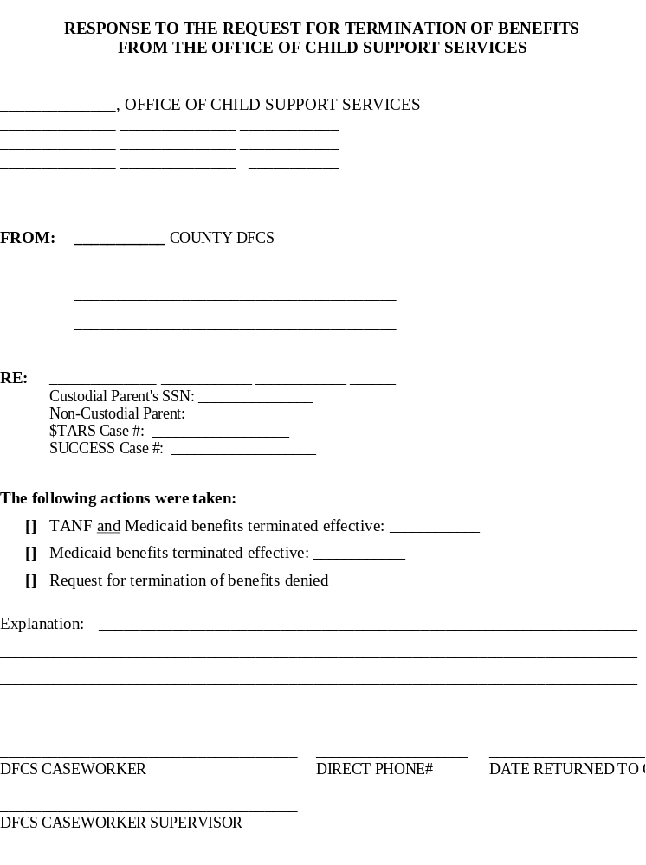



20 DAYS
Deadline to provide evidence

30 DAYS
Deadline to determine Good Cause at change or review

45 DAYS
Deadline to determine Good Cause at application

2 DAYS
Notify the A/R of the decision

10 DAYS
Allow the A/R to choose an option:
Cooperate with CSS
Request termination for
non-cooperating adult
Request a hearing
Withdraw the application

CRITERION | LIM | RSM
Failure to comply with: | Penalty applies to: | Penalty applies to:
  Child Support | Parent  - A child is neither penalized nor excluded for an adult’s failure to cooperate.  - Pregnant women are not required to cooperate for the unborn child. | Parent  - A child is neither penalized nor excluded for an adult’s failure to cooperate.  - Pregnant women are not required to cooperate.

CHANGE NON-FINANCIAL ELIGIBILITY RESULTS - ELIG ELIG A
Month 11 06 9991 10 02 06 01

AU ID 176000184 Prog MA Prog Type F Med COA F01
Confirm

AU AU Status AU Stat Appl Begin Pd Thru ---Penalty---
Stat Reasons Date Date Date Date Type End Date
A 100206 100206 100106
------------------------------------------------------------------------------
First Last Rel V Mand Finl --Stat-- Rsn Appl Begin Pd Thru Penalty
Name Name Incl Resp Date Date Date Date T Date
KATHER NOR SE OT Y SA A 100206 228 100206 100106 10312006
LISA NOR CH OT Y RE A 100206 100206 100106
JOEY NOR CH OT Y RE A 100206 100206 100106

Message

SA – Sanctioned

228 – Failed to cooperate with child support

CHANGE CASH ASSISTANCE FINANCIAL ELIGIBILITY - CAFI CAFI A
Month 11 06 4981 10 05 06
AU ID XXXX00184 Prog MA Prog Type S Med COA F01
Net Income Test (cont)
Resources Standard – 30 1/3 265.97
Resources Limit 1000.00 Dependent Care 43.33
Total Resources 133.00 Net Earned Income 248.61
Gross Income Test Net Unearned Income 50.00
Gross Income Limit 658.60 Deemed Income .00
Gross Earned Income 557.91 Allocated Income .00
Net Unearned Income 50.00 Net Income 299.00
Deemed Income .00 Grant Amount .00
Allocated Income .00 Recoupment Amount .00
Total Gross Income 607.91 Benefit Amount .00
Net Income Test Previous Benefit .00
Net Income Limit 356.00 Spenddown Amount
Gross Earned Income 557.91 Medical Expense Amt
Self Employ Work Exp .00 Net Spenddown Amt
Bnft Eff Date 100506 Bnft Confirm Reasons 233 324 Budgeting Method P
Notice Type 0010 Waive Timely Notice Period Notice Override
Review Begin Dt 10 06 Review End Dt 04 07 Strat 3

Message

13-note

Family Medicaid Financial Limits
 | LIM | LIM
NUMBER IN AU | GROSS INCOME CEILING (GIC) | STANDARD OF NEED (SON)
1 | $435 | $235
2 | $659 | $356
3 | $784 | $424
4 | $925 | $500
5 | $1,060 | $573
6 | $1,149 | $621
7 | $1,243 | $672
8 | $1,319 | $713
9 | $1,389 | $751
10 | $1,487 | $804
11 | $1,591 | $860
12 | $1,635 | $884
(+) PER ADDITIONAL BG MEMBER | $44 | $24
Georgia Department of Human Resources
TANF / FAMILY MEDICAID/ CHILD SUPPORT SERVICES

COMPLIANCE AGREEMENT

_______________________ County Department of Family and Children Services

For DFCS Use Only
____________________________________________ _____________________________________
Grantee Relative Name Date Mailed / Given

____________________________________________ _____________________________________
Grantee Relative Address Case Manager / Load #

____________________________________________ _____________________________________
SUCCESS AU ID # Telephone / Fax Number

Date of Compliance Request: _______________________

I understand that TANF cash assistance was terminated for my assistance unit and/or my Family Medicaid benefits were terminated because I failed to cooperate with the Office of Child Support Services (OCSS).

In order to receive TANF cash assistance and/or Family Medicaid benefits again, I understand that I must cooperate with the OCSS by assisting in one or more of the following activities:

- Locating the absent parent(s) of the children for whom I receive assistance
- Establishing legal paternity, if necessary, and
- Establishing or enforcing a child support order.

I agree to contact the OCSS within 10 calendar days of the date of this compliance agreement and if necessary, schedule an appointment. I understand that if I fail to cooperate with the OCSS, my family and I will not be eligible for TANF cash assistance, and I will not be eligible for Family Medicaid benefits.

The telephone number of the local office of child support services is _____________________________.

I must be in compliance with the office of child support services no later than _____/_____/_____.

Applicant’s Signature: _________________________________ Email Address: _________________________
Applicant’s Telephone Number: _________________________ Applicant’s Cell Number: _____________________
Case manager’s Signature: _________________________________________

For OCSS Use Only
- Cooperated on __________________________________
- Did not Cooperate as of ___________________________
- Did not contact OCSS as of ________________________

Comments: ____________________________________________________________________________________________

________________________________________________ __________________________
OCSS Agent / Case Manager’s Signature Date

_______________________________
OCSS Case #

Form 5706 (Rev.01/2007)

CHILD SUPPORT SERVICES Exercise

Ms. Mary Barber applies for LIM on 1/15 for herself and her child, Juliet (7). The family’s only income is a contribution she receives from her parents of $200/month.

At the interview, Ms. Barber states that the father of her child, Tom Warner, does not pay child support and does not provide health insurance coverage for Juliet.

Ms. Barber provides all known information to the Case Manager at the interview. She provides the last known address, telephone number, demographic, and employer information during the interview.




